LAB ASSIGNMENT:1.4
NAME: VAISHNAVI VARDINENI
HT NO:2403A51431
BATCH:16

SCREENSHOT:



TASK 2:
SCREENSHOT:
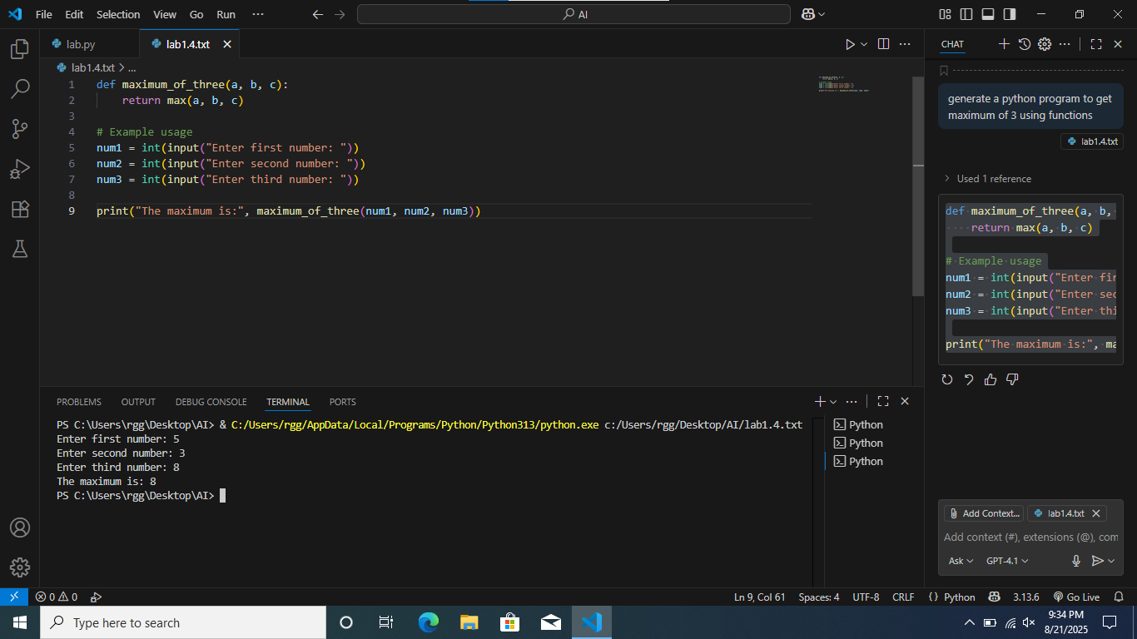
EXPLANATION:
The program defines a function maximum_of_two(a, b) that returns the larger of two numbers.
It takes two inputs from the user, calls the function, and prints the maximum

TASK 3:
SCREENSHOT:
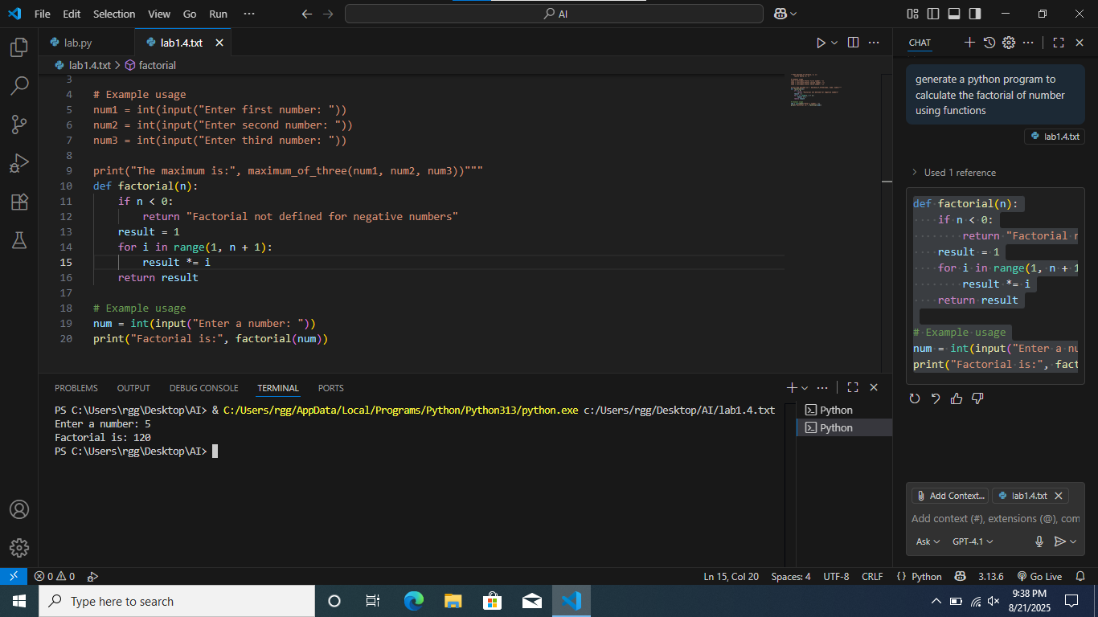
EXPLANATION:
This program defines a function factorial(n) that calculates the factorial of a number n using a loop.
It takes an integer input from the user and prints the factorial result.
If the input is negative, it returns a message saying factorial is not defined for negative numbers.

TASK 4:
SCREENSHOT:
EXPLANATION:
This program defines a Student class with attributes for name, roll number, and marks.
It includes a method display_details() to print the student's details.
An example creates a student object and displays its information.

TASK 5:
SCREENSHOT:
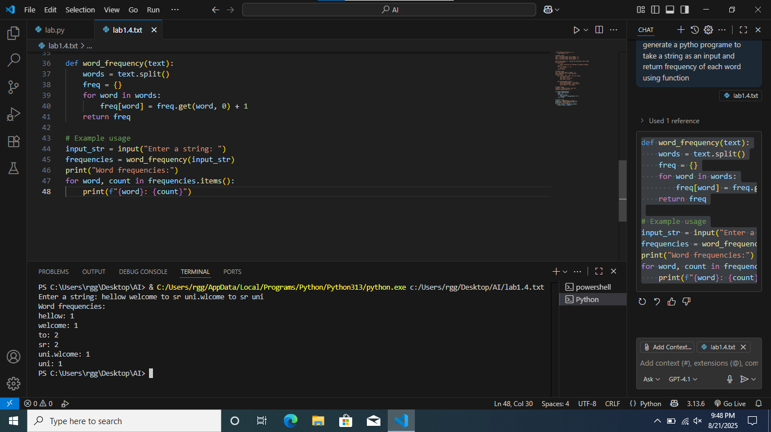
EXPLANATION:
This program defines a function word_frequency that counts how many times each word appears in a given string.
It takes a string input from the user, calculates word frequencies, and prints each word with its count.

